**What is the impact of illegal Israeli settlements in the West Bank?**

**Lesson 16**

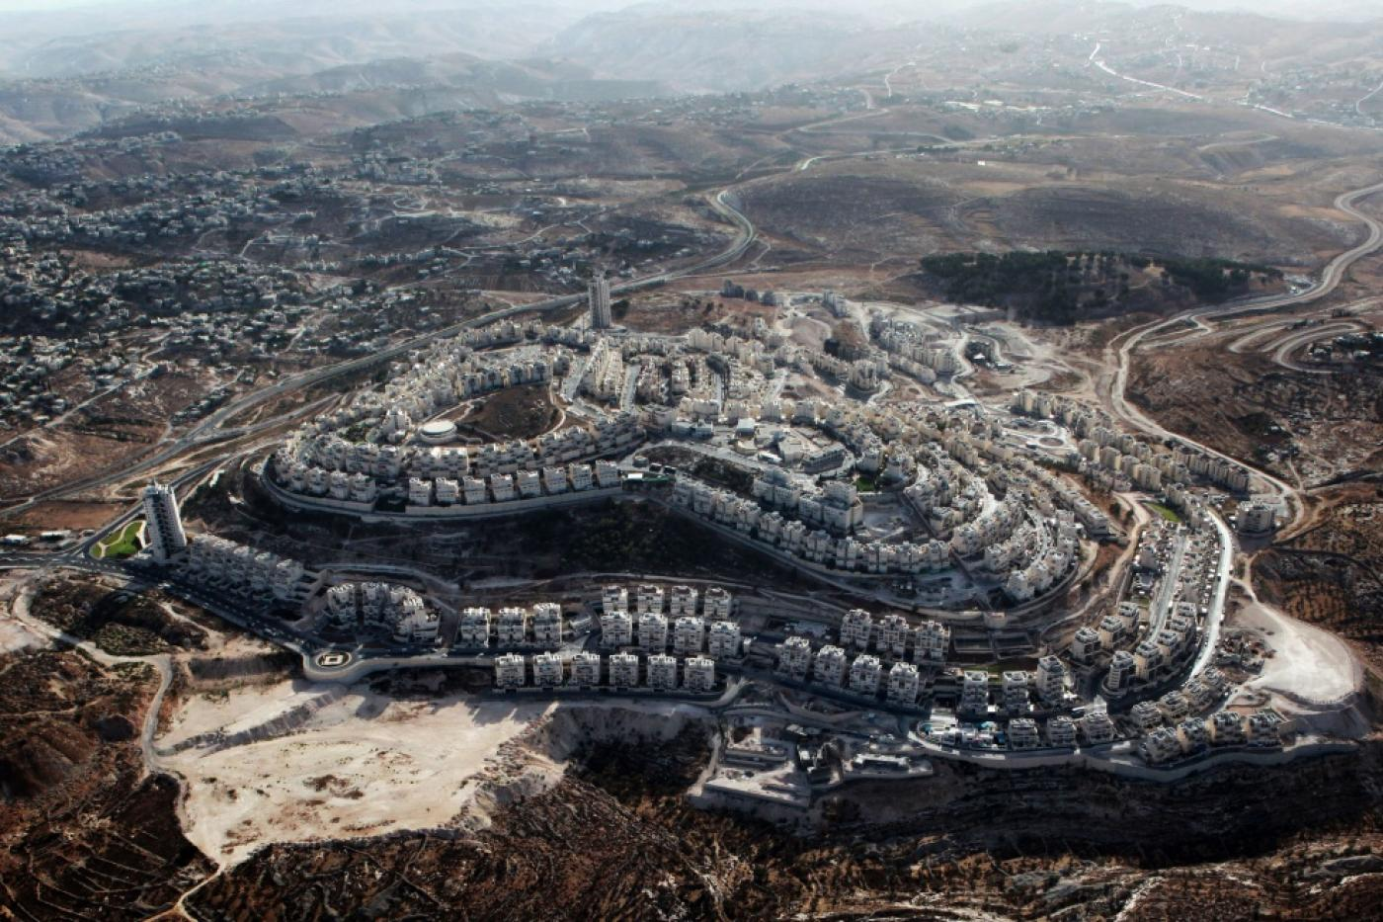

1 of 250 illegal Israeli settlements across the West Bank

**By the end of this lesson, you should be able to:**

Describe what an illegal Israeli settlement is

Explain why this is illegal under international law

Discuss the impact of this on Palestinians in the West Bank

**Keywords**

Illegal Israeli settlement

Israeli settler

International law

Fourth Geneva Convention

Checkpoints

**Knowledge check!**

1)Where is the West Bank on this map of Palestine-Israel from Lesson 1?

2)What happened to the West Bank in 1948 and 1967?

3)Can you remember why it is called the West Bank?

**Illegal Israeli settlements**

*The establishment of an Israeli community on Palestinian land. This violates international law, specifically the Fourth Geneva Convention*

**Israeli settler**

*Someone with Israeli citizenship who makes a home on Palestinian land*

**How many illegal Israeli settlements are there?**

In May 2021 there were **250 settlements** across the West Bank and East Jerusalem, home to between **600,000 and 750,000** **Israeli settlers**

**What is international law?** Laws on the relationships between countries

**What is the Fourth Geneva Convention?** An agreement about how civilians should be treated in war zones, from 1950

**What do you want to know about illegal Israeli settlements?**

Write down two or three things you want to know about illegal Israeli settlements

Discuss what you have written down with the person next to you

**Why do people choose to settle in the occupied West Bank?**

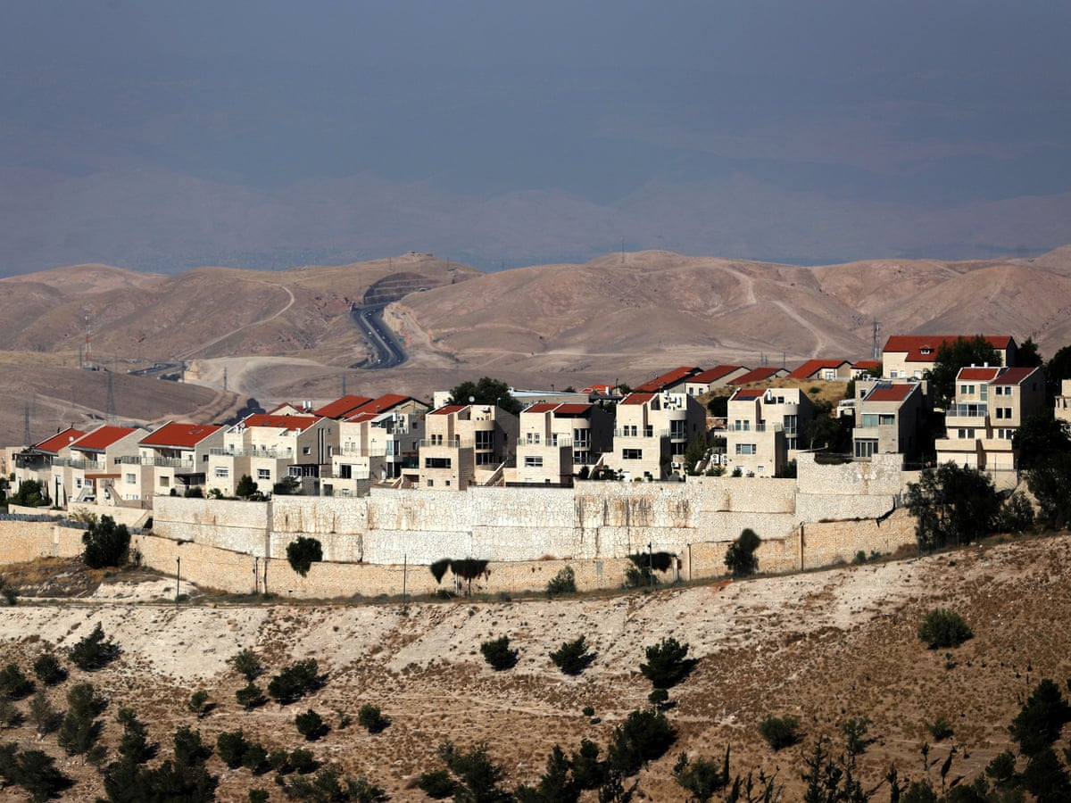

People choose to settle in the occupied West Bank for a number of reasons

-**Zionists** believe that all of historic Palestine-Israel should be a Jewish state

-Houses are cheaper in the occupied West Bank than in Israel because they are subsidised by the Israeli government. This means that settlers can afford **bigger homes**

-Some religious Jews believe that **God gave Palestine-Israel to the Jews**

-The cost of living is lower in the occupied West Bank than in Israel, so settlers have a **higher quality of life for cheaper**

-Some religious Jews believe that by settling in the West Bank they are **serving God’s will** and will bring about the coming of the Messiah

**Activity**

Create a spider diagram grouping these reasons into *political, economic, social and religious* motives

Are any of these reasons linked? Why?

**Why are settlements illegal?**

In 1967 Israel occupied the West Bank (it invaded and took control)

According to international humanitarian law, it is illegal for a country to move its population into a territory it has occupied. This means that **it is illegal for Israel to move its population into the West Bank because the West Bank is occupied territory**

This is set out in Article 49 of the Fourth Geneva Convention:

“The Occupying Power shall not deport or transfer parts of its own civilian population into the territory it occupies”

**Activity**

In your book write two sentences explaining why Israeli settlements in the West Bank are illegal under international law. Try to use the term ‘occupation’ in your answer

**What does the UN say?**

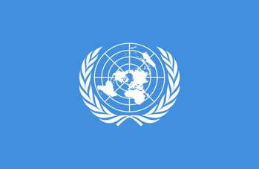

In 1967, the UN passed **Resolution 237**, which condemned Israeli settlements in the occupied West Bank

Since then, manyUN Resolutions have condemned Israeli settlements:

-Resolution 237 in 1967

-Resolution 252 in 1968

-Resolution 267 in 1969

-Resolution 271 in 1969

-Resolution 298 in 1971

-Resolution 465 in 1980

-Resolution 2334 in 2016

Resolution 2334 of 2016 says that Israeli settlements on occupied Palestinian land have **‘no legal validity… a flagrant violation under international law’**

**Activity**

Copy out and fill in this table:

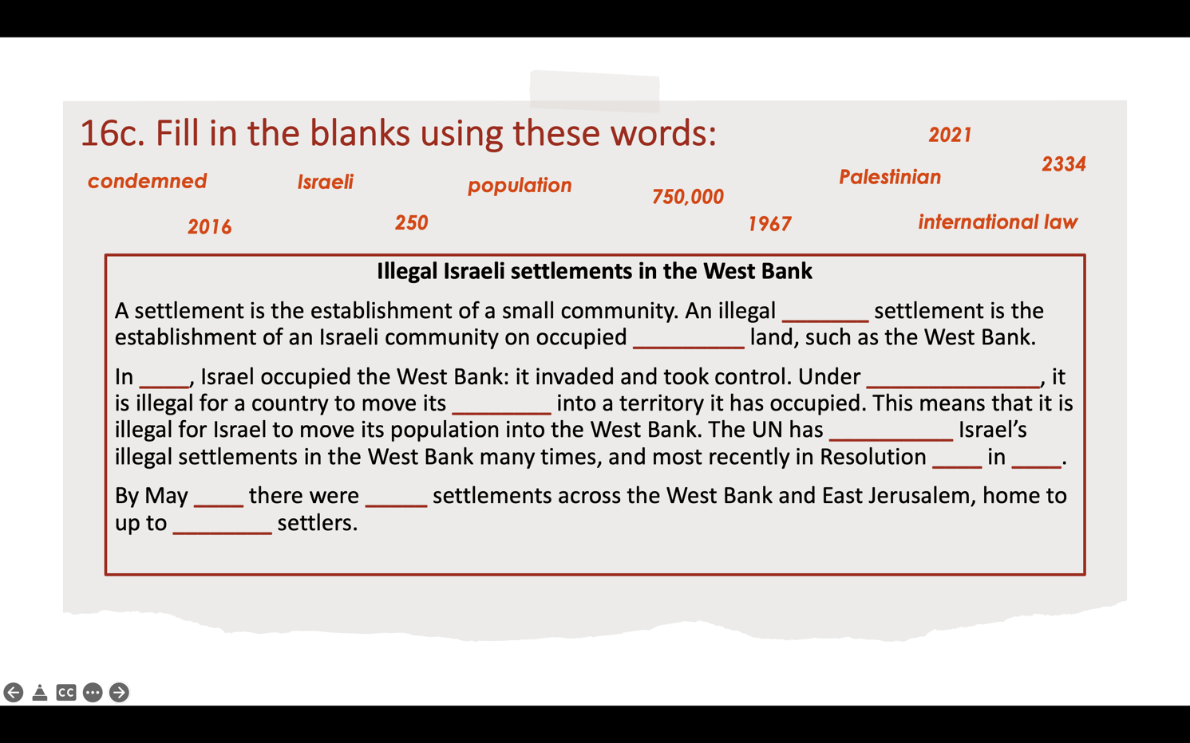

**What is the impact of illegal Israeli settlements on Palestinians in the West Bank?**

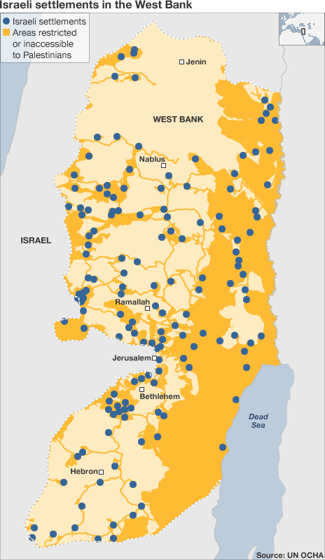

Some of the impacts on Palestinians include:

-**Loss of land**

-**Home demolitions**: Since 2004, 1000 Palestinian homes have been destroyed by Israel to make way for settlements

-**Settler violence:** settlers often attack Palestinians. In the first 6 months of 2021, there were 273 incidents of this

-**Breaking up the land of a future Palestinian state:** What would a future Palestine look like? Where would the border be?

-**Roads**: New settler-only roads have been built in the West Bank. Palestinians are not allowed to use these. They have to use older, longer routes instead

**Discussion question**

Is this fair? Think about this from both a Palestinian and an Israeli settler perspective

**Question**

What does this infographic tell you about the impact of illegal Israeli settlements on Palestinian life in the West Bank?

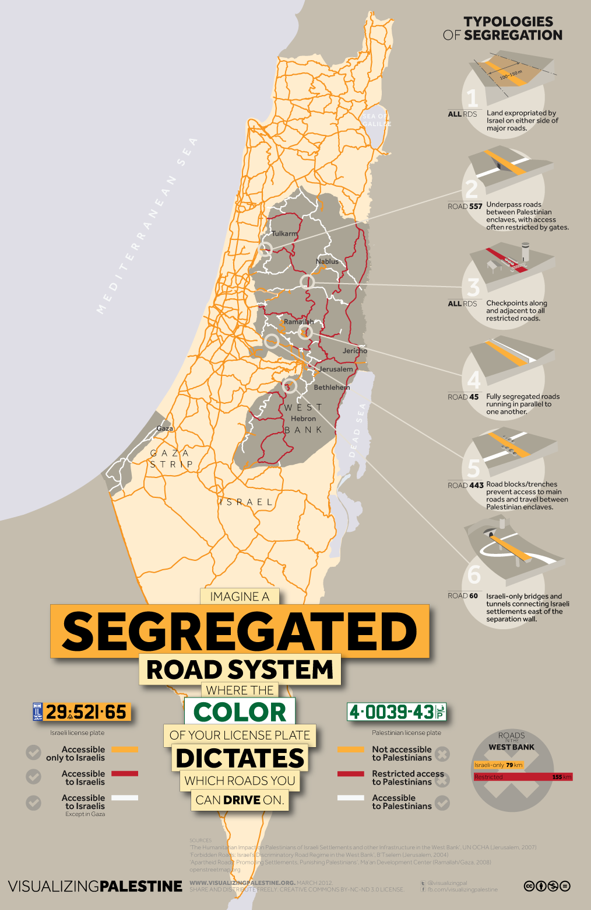

**Case study: Hebron**

Hebron is a city in the south of the West Bank. It is home to 200,000 Palestinians, 600 illegal Israeli settlers and 2000 Israeli soldiers

The illegal Israeli settlements make life **very difficult** for Palestinians in Hebron

In the city of Hebron, there are 86 checkpoints, roadblocks or physical obstructions controlled by Israeli soldiers. They divide Hebron into Israeli and Palestinian areas. This severely restricts Palestinian freedom of movement

**Checkpoints**

*Barriers set up by Israel to control and restrict Palestinian movement. In 2020 there were nearly 600 checkpoints across the West Bank*

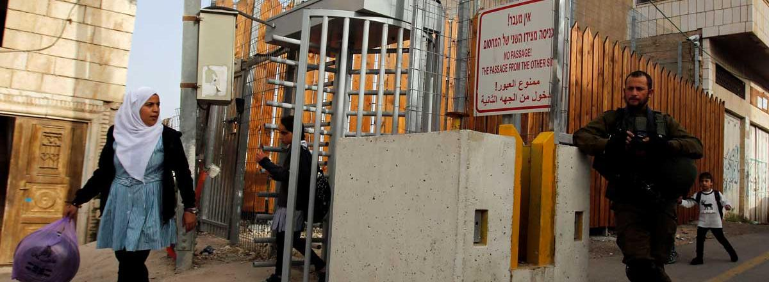

**Debate**

You are now going to be assigned a partner. You and your partner are either **‘support’** or **‘opposition’** to illegal Israeli settlements. You can spend a few minutes preparing your argument

Support for Israeli settlements:

*Ideas:*

-Israel occupied the West Bank in 1967, so Israeli citizens should be able to live here now

-Houses are cheaper in the West Bank so Israelis can afford bigger houses

-The cost of living is lower in the West Bank, so Israelis can enjoy a higher quality of life for cheaper

Opposition to Israeli settlements:

*Ideas:*

-‘Occupation’ is meant to be *temporary*. Israel should now give the West Bank back to the Palestinians

-Palestinians have lived in the West Bank for centuries. It is their ancestral land

-Israeli settlements are illegal under international law. They violate Article 49 of the Fourth Geneva Convention

Join with another pair and have a debate about this. Note down the best points made by the other side

**Food for thought**



In 2021, Ben and Jerry’s announced that it would not renew its licensing agreement in the occupied West Bank due to Israel’s illegal settlements on Palestinian land. Co-founders Ben and Jerry explained that settlements ‘violate the basic human rights of the Palestinian people[’](https://www.benjerry.com/about-us/media-center/opt-statement). Do you think more companies should take a stand against illegal Israeli settlements?

**Extension question**

Should illegal Israeli settlement building in the West Bank continue? Why or why not?

Use what you have learnt in this lesson to justify your answer